Proposal to mint and sell a set of “success tokens” in collaboration with UMA to diversify treasury and raise some stablecoin for operational reasons. It’s good to diversify our treasury with a range of stable coins which provide a hedge against a down crypto market. This way we will have a more resilient treasury to handle multiple possible bear market conditions. We have lots of GIV, let’s not keep all our eggs in one basket.

**How it works**

Range tokens: DAO taking a loan, without liquidation risk, instead of selling tokens - a sort of “crypto native convertible debt.

You use the native asset to borrow stablecoins with the preset value range and generate interest from VC investors by selling the range token at a discount.

If the contract expires within the range, it offers a yield (25% as seen on the Sushi forum and UMA’s experience, though this may depend on the set range). If the Range Token expires above range, there is some exposure to the upside but it’s capped. Assuming it expires below the range, there is exposure to the downside. The yield % will drop accordingly but the assets are still protected from liquidation.

Difference vs. Success tokens: With the UMA success token, you essentially wrap two tokens. One, the native asset. The other is the option that only provides value to the buyer if the native asset expires above the strike value and does not create sell pressure on the GIV token.

It is better for those who want long exposure to GIV. It also requires less GIV collateralization up front.

If the expiration price is below the strike price, the investor only receives the project token portion and does not receive any portion of the collateral backing the covered call option. If the expiration price is above the strike price, the call option pays investors an additional amount demonstrated as the bonus value below:

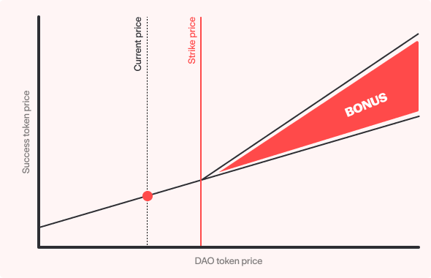

(1) this allows the DAO to effectively leverage (take on debt) against its treasury now, with the hope of paying back that debt at a higher GIV price than today in order to ensure it has the necessary stable coin funds for various operational expenses it may want to pay out (when not paying directly in GIV or even paying a combo of the two).

(2) The DAO retains the upside on the GIV up to the max of the range.

(3) there is no liquidation risk on the loan.

This is a smart and innovative way to diversify our treasury without selling the GIV to the market now and we can be bullish on our own token.

**Success Token Example**

An example contract we will refer to throughout the success token sections is a success token issued by the UMA treasury (stUMA-1221) with several VC investors that agree to create a success token which combines 1 $UMA token with a $15 strike $UMA call option backed by 0.5 $UMA tokens.

The value of the success token would depend on the UMAUSD price at expiry:

If the price is less than $15, each long is worth 1 $UMA, because the embedded call option expired worthless.

If the price expired at $30, the success token value in UMA would be calculated using 1 + (( 0.5 ) * ( $30 - $15 ) / $30 ) = 1.25 $UMA per success token. In dollar value, 1 stUMA-1221 with a $30 expiry price would be worth $30.00 * 1.25 = $37.50.

**Structure**

Token Name: sc-

Size: ## sc-

Maturity: mm dd, yyyy

Price: ## USDC

Total Value: ## USDC

Collateral: ## $GIV

Links:

<https://medium.com/uma-project/success-tokens-an-incentive-aligned-way-for-vc-funds-to-invest-in-daos-1e8b8244f2f4>

<https://medium.com/uma-project/treasury-diversification-with-range-tokens-145d4b12614e>

<https://docs.umaproject.org/success-tokens/summary>

<https://medium.com/@ShapeShift.com/the-success-token-scfox-what-is-it-cf506a9afb53>